**lab assignment# 4**

Name: Muhammad Ahmed Naseer

sec: ME-15(A)

id: 467276

course: Fundamentals of Programming (lab)

**Hometask # 1:**

#include <iostream>

using namespace std;

int main(){

int a=0;

for( int b=0; b<150; b++)

//the loop will rum 149 times

{

if(b%10==0)

//any divisible of 10 will be excluded from cout

{

continue;

}

else{

cout<<b<<" , ";

}

}

return 0;

}

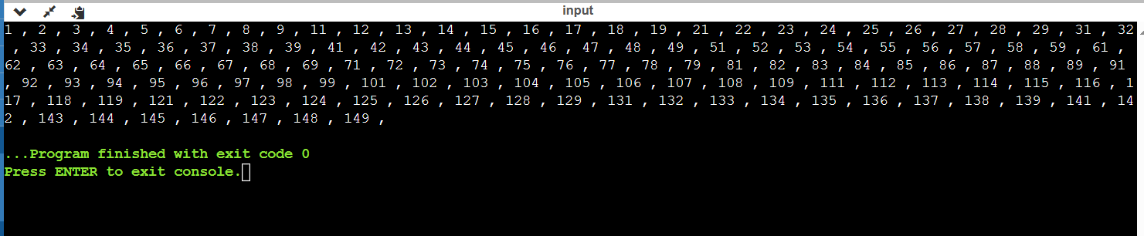

**Hometask # 2:**

#include <iostream>

using namespace std;

int main(){

int a,b,c=0;

cout<<"Enter number:";

cin>>a;

while(a>0)

{

b=a%10;

c=c+b;

a=a/10;

//here the number is first divided by 10 to get units value and then again divided by 10 to get tens value

}

cout<<"sum of digits:"<<c<<endl;

return 0;

}

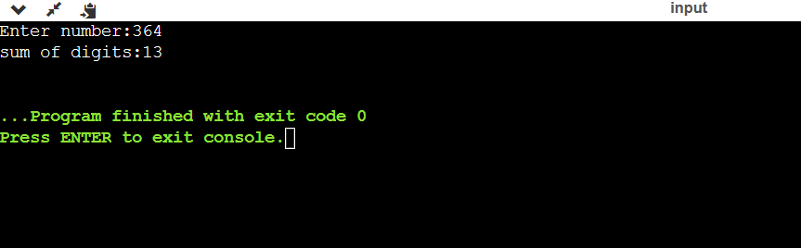

**Hometask # 3:**

#include <iostream>

using namespace std;

int main(){

int a,b;

cout<<"Enter a number:";

cin>>a;

if(a==1||a==0){

cout<<"your number in niether prime nor composite";

}

else{

for(b=2;b=a/2;b++){

if(a%b==0){

cout<<"your number is composite";

} else{

cout<<"your number is prime";

}

break;

}

}

return 0;

}

